A HYBRID FRAMEWORK FOR AI BASED CYBER THREAT DETECTION SYSTEM
PROJECT REPORT PHASE I
Submitted by
ABDUL PATHIAQ.A (22TH0102)
DAVID RAJ.M (22TH0112)
GOPINATH.G (22TH0116)
JAYAPRADAP.J (22TH0122)
Under the guidance of
Mrs. R. Ranjani., M.E., (Ph.D)
Senior Assistant professor,
Department of Information Technology.

To the Pondicherry University, in partial fulfillment of the requirement for the award for degree
BACHELOR OF TECHNOLOGY
IN
INFORMATION TECHNOLOGY

DEPARTMENT OF INFORMATION TECHNOLOGY
CHRIST COLLEGE OF ENGINEERING AND TECHNOLOGY
PUDUCHERRY - 605 010
NOV-2025

A HYBRID FRAMEWORK FOR AI BASED CYBER THREAT DETECTION SYSTEM

PROJECT REPORT PHASE 1
SUBMITTED BY

ABDUL PATHIAQ A (22TH0102)
DAVID RAJ M (22TH0112)
GOPINATH G (22TH0116)
JAYAPRADAP J (22TH0122)

DEPARTMENT OF INFORMATION TECHNOLOGY

CHRIST COLLEGE OF ENGINEERING AND TECHNOLOGY
PUDUCHERRY - 605110

CHRIST COLLEGE OF ENGINEERING AND TECHNOLOGY
PUDUCHERRY – 605110

DEPARTMENT OF INFORMATION TECHNOLOGY

BONAFIDE CERTIFICATE

This is to certify that the Project Phase–1 Work titled “A HYBRID FRAMEWORK FOR AI BASED CYBER THREAT DETECTION SYSTEM” is a bonafide record of the work done by ABDUL PATHIAQ A (22TH0102), DAVID RAJ M (22TH0112), GOPINATH G (22TH0116) and JAYAPRADAP J (22TH0122) in partial fulfilment of the requirements for the award of the Degree of Bachelor of Technology in Information Technology of Pondicherry University during the academic year 2025 – 2026, and this work has not been submitted for the award of any degree of this/any other institution.

PROJECT GUIDE
Mrs. R. Ranjani., M.E., (Ph.D)
Senior AP/IT
HEAD OF THE DEPARTMENT
Mr. MANL J.
M.E..(Ph.D).,M.LS.T.E

Submitted for the University Examination held on ___________.

INTERNAL EXAMINER
EXTERNAL EXAMINER

ACKNOWLEDGEMENT
It gives a great pleasure in taking privilege to express our gratitude to one and all who have extended their kind gesture to finish our Project work. First and foremost, we would like to express our great gratitude to our beloved the Chairman and Managing Director of our college Dr.SAMPAUL.,M.E.,Ph.D., Principal Dr. A. Sivakumar. M.E..,Ph.,M.I.S.T.E., Christ College of Engineering and Technology.We are thankful and grateful to our Project guide Mrs. R. Ranjani., M.E., (Ph.D) Senior Assistant Professor and Project Coordinator Mr.J.MANI.,M.E.,Ph.D.,M.I.S.T.E., Head of the Department for his valuable guidance, keen interest, timely suggestions and great support given during the entire project.Would also like to thank all the Staff Members of the Department of Information Technology for their fullest support and encouragement. Above all we wish to express our wholehearted gratitude to our family members and friends who stood with us throughout the span of this project work. In the praise Almighty we thank one and all.
ABDUL PATHIAQ.A
DAVID RAJ.M
GOPINATH.G
JAYAPRADAP.J
TABLE OF CONTENTS

CHAPTER NO TITLE PAGE NO
I
II
III

Abstract
List of Abbreviations
List of Figures

10
CHAPTER 1
- Introduction
1.1 Overview of Cybersecurity
1.2 Need for Cyber Threat Detection
1.3 Problem Statement
1.4 Objectives of the Project
1.5 Scope of the Project
1.6 Expected Outcome / Deliverables
1.7 Applications of the System
13
CHAPTER 2
- Background Study
2.1 Introduction to Cyber Threats & Attacks
2.2 Existing Cyber Threat Detection Techniques
2.3 Limitations of Existing Systems
2.4 Role of AI & ML in Modern Cybersecurity
2.5 Research Gap Identification
CHAPTER 3
16
System Analysis
3.1 Proposed System Overview
3.2 Hybrid AI-based Threat Detection Framework
3.3 Modules Description
3.4 System Requirements (Hardware & Software)
3.5 Feasibility Study (Technical, Economic, Operational)
3.6 Project workflow description
3.7 Sample Result and Output Explanation
CHAPTER 4
22
System Design & Methodology
4.1 Architecture of the Proposed System
4.2 Data Flow Diagram (DFD Level 0,1,2)
4.3 UML Diagrams (Use Case, Sequence, Class Diagram)
4.4 Dataset Description (NSL-KDD / CIC-IDS-2017 etc.)
4.5 Algorithms Used and Modules Workflow
CHAPTER 5
26
Conclusion
CHAPTER 6
27
References
ABSTRACT
With the rapid growth of the internet and digital technologies, cybersecurity threats have become increasingly sophisticated, frequent, and complex. Traditional security mechanisms are often insufficient to detect and prevent modern cyber attacks, which include malware, denial-of-service attacks, phishing, and advanced persistent threats. To address this challenge, this project proposes “A Hybrid Framework for AI-Based Cyber Threat Detection System”, which integrates multiple Artificial Intelligence (AI) and Machine Learning (ML) techniques to improve the accuracy and efficiency of detecting cyber threats in real-time.The hybrid framework combines supervised and unsupervised learning approaches to analyze network traffic data, extract key features, and classify potential threats. Datasets such as NSL-KDD and CIC-IDS2017 are utilized to simulate real-world network environments. Numeric network features such as packet duration, protocol type, source and destination bytes, connection count, and other statistical attributes are processed to train AI models capable of recognizing patterns associated with normal and malicious activities. The system is designed to reduce false positives and false negatives by leveraging ensemble techniques and intelligent feature selection.The project model, demonstrates a simplified version of the framework where users can input numeric network features to predict potential cyber threats. The model serves as a prototype to showcase the functionality of hybrid AI-based detection systems, providing valuable insights into the practical implementation of intelligent cybersecurity solutions. This framework aims to enhance network security monitoring, threat prevention, and decision-making for cybersecurity analysts. The hybrid approach ensures adaptability to evolving attack patterns and improves detection speed compared to conventional signature-based systems. The outcomes of this project provide a foundation for future enhancements, including real-time deployment in enterprise networks, integration with automated incident response systems, and expansion to cover emerging cyber threats. In conclusion, this project highlights the potential of AI and ML in modern cybersecurity, demonstrating how a hybrid detection system can contribute to safer, smarter, and more resilient network environments.

LIST OF ABBREVIATIONS
AI Artificial Intelligence
ML Machine Learning
DL Deep Learning
ANN Artificial Neural Network
CNN Convolutional Neural Network
RNN Recurrent Neural Network
IDS Intrusion Detection System
IPS Intrusion Prevention System
NSL Network Security Laboratory
KDD Knowledge Discovery in Databases
CIC Canadian Institute for Cybersecurity
EDA Exploratory Data Analysis
MSE Mean Squared Error
MAE Mean Absolute Error
ROC Receiver Operating Characteristic
AUC Area Under Curve
DDoS Distributed Denial of Service
TCP Transmission Control Protocol
UDP User Datagram Protocol
FTP File Transfer Protocol
List of Figures
Fig 2.1 Cyber Threats & Attacks
Fig 3.1 Project Workflow Description
Fig 4.1 System Architecture
Fig 4.2 Data Flow Diagram

CHAPTER 1
INTRODUCTION
In today’s world, the rapid expansion of digital technology and internet usage has led to an increase in cyber threats and attacks. Organizations, governments, and individuals face serious security challenges such as malware, phishing, ransomware, and Distributed Denial of Service (DDoS) attacks. Traditional security measures, such as firewalls and signature-based antivirus systems, are no longer sufficient to detect evolving threats in real-time. Cybersecurity involves protecting computer systems, networks, and data from unauthorized access, misuse, and attacks. With the emergence of Artificial Intelligence (AI) and Machine Learning (ML), it is possible to design intelligent systems that can detect, predict, and respond to cyber threats with higher accuracy and efficiency.
1.1 Overview of Cybersecurity
Cybersecurity involves protecting computer systems, networks, and data from unauthorized access, attacks, and damage. It ensures the confidentiality, integrity, and availability of information, which are essential for the smooth functioning of modern digital systems. Cybersecurity can be divided into multiple domains, including network security, information security, application security, operational security, and disaster recovery. Network security focuses on safeguarding organizational networks against intrusion and malicious activity. Information security ensures that sensitive data is protected from theft, alteration, or unauthorized disclosure. Application security involves designing software that is resistant to vulnerabilities and attacks, while operational security implements policies and procedures to manage and secure data during routine operations. Disaster recovery and business continuity planning help organizations respond effectively to cyber incidents, minimizing potential disruption. AI and ML technologies enhance these domains by enabling automated monitoring, anomaly detection, and intelligent threat prediction, thereby improving overall system resilience.

  - Need for Cyber Threat Detection
The need for efficient cyber threat detection has become critical due to the increasing complexity and frequency of cyber attacks. Traditional systems relying on static rules or manual monitoring are often unable to detect new or evolving threats, resulting in high false positive and false negative rates. AI-based detection systems address this challenge by analyzing network traffic in real-time, learning from historical data, and classifying activities as normal or malicious. These intelligent systems provide actionable insights to cybersecurity analysts, enabling faster response to potential threats and reducing the impact of attacks. The proposed hybrid AI framework ensures that organizations can proactively monitor their networks, predict potential attacks, and respond effectively to safeguard their digital assets.
  - Problem Statement
Traditional cybersecurity solutions are limited by their dependence on predefined rules and signature-based detection methods. Modern cyber threats are dynamic, adaptive, and often designed to bypass conventional defenses. This project addresses the problem of developing an AI-based hybrid framework that can detect cyber threats accurately and efficiently while adapting to evolving attack patterns. By combining multiple machine learning techniques, the system aims to reduce false alerts, improve detection accuracy, and provide a scalable solution for modern network environments.
  - Objectives of the Project
The primary objectives of this project are to design a hybrid AI-based system capable of detecting cyber threats in network traffic, utilize machine learning and deep learning algorithms for classifying normal and malicious behavior, and minimize false positives while improving detection accuracy. The project also involves developing a functional prototype where numeric network features can be input to predict potential threats. Furthermore, the system aims to provide a foundation for future deployment in real-time enterprise networks and integration with automated cybersecurity response mechanisms. These intelligent systems provide actionable insights to cybersecurity analysts, enabling faster response to potential threats and reducing the impact of attacks. The proposed hybrid AI framework ensures that organizations can proactively monitor their networks, predict potential attacks, and respond effectively to safeguard their digital assets.

1.5 Scope of the Project
The scope of the project includes implementing a hybrid AI framework that integrates multiple machine learning models for robust threat detection. It focuses on analyzing structured network traffic datasets such as NSL-KDD and CIC-IDS2017 for training and testing the models. The project also involves creating a prototype system for simplified numeric input and threat prediction. Additionally, the project lays the groundwork for future enhancements, including real-time deployment in enterprise networks and expansion to detect emerging cyber threats.
  - Expected Outcomes
The expected outcomes of this project include efficient detection of cyber threats with improved accuracy, development of a hybrid AI system combining multiple learning techniques, and a functional prototype demonstrating threat prediction using numeric network features. The project also aims to provide insights for future research and implementation of real-time AI-based cybersecurity solutions, ultimately contributing to safer and more resilient network environments
1.7 Applications of the System
The hybrid AI-based cyber threat detection system has numerous practical applications. In enterprise networks, it can be used for real-time monitoring and proactive threat detection. Government organizations can employ the system to secure critical infrastructure, while financial institutions can use it to prevent fraud, phishing, and data breaches. Educational institutions can safeguard student and staff information, and research organizations can utilize the framework as a foundation for developing future AI-driven cybersecurity solutions. The proposed hybrid system provides a versatile and adaptive solution capable of addressing the challenges of modern cybersecurity.

CHAPTER 2
BACKGROUND STUDY
2.1 Introduction to Cyber Threats & Attacks
The rapid growth of digital communication, e-commerce, cloud platforms, and interconnected devices has resulted in an increased exposure to cyber threats across all sectors. A cyber threat refers to any malicious act intended to steal, damage, or disrupt data, networks, or digital systems. Cyber attacks can originate from individual hackers, organized cybercriminal groups, or state-sponsored entities targeting government, business, or personal information. Common cyber attacks include malware, ransomware, phishing, identity theft, Distributed Denial of Service (DDoS), SQL injection, and advanced persistent threats (APTs). These attacks are becoming more sophisticated, stealthy, and automated due to advancements in technology. Organizations face severe consequences such as financial loss, reputational damage, service interruption, and data breaches when subjected to cyber attacks. As technology evolves, attackers continuously modify their tactics, making traditional protection mechanisms insufficient. This situation highlights the urgent need for advanced, adaptive, and intelligent cybersecurity systems capable of analyzing patterns, predicting potential threats, and responding proactively to malicious activities.
2.2 Existing Cyber Threat Detection Techniques
Traditional cyber threat detection techniques primarily rely on signature-based and rule-based mechanisms that match known attack patterns or signatures with incoming network traffic. Signature-based Intrusion Detection Systems (IDS) identify threats using a database of previously discovered attack signatures, making them effective for detecting known threats. Rule-based systems, such as firewalls and access control lists, operate based on predefined rules that determine whether network traffic is permitted or blocked. Another widely used technique is anomaly-based detection, which monitors system behavior to detect deviations from normal patterns. Although anomaly detection helps identify unknown attacks, it often results in high false positive rates. Security Information and Event Management (SIEM) tools are also used to collect and analyze security logs for threat detection.
2.3 Limitations of Existing Systems
Despite widespread use, traditional cyber threat detection systems face several limitations that reduce their effectiveness in modern network environments. Signature-based systems cannot detect new or unknown threats until their signatures are identified and updated in the database, allowing zero-day attacks to bypass security defenses. Rule-based systems struggle to adapt to dynamic and complex network traffic, leading to inefficiencies and delays in responding to threats. Anomaly detection methods, although capable of identifying abnormal behavior, often generate a high volume of false alarms, making it difficult for cybersecurity analysts to distinguish between genuine threats and normal variations. Manual monitoring and log analysis require significant time and skilled expertise, making the process labor-intensive and error-prone. Additionally, traditional security tools operate in isolation rather than integrating data from multiple sources, limiting their accuracy and threat visibility. These limitations create a strong need for intelligent and autonomous models that can learn, adapt, and detect threats more accurately.
2.4 Role of AI & ML in Modern Cybersecurity
Artificial Intelligence (AI) and Machine Learning (ML) play a transformative role in enhancing cybersecurity by enabling automated, intelligent, and real-time threat detection. Unlike traditional security methods, AI-powered systems can analyze large volumes of data, identify complex patterns, and learn from past cyber attacks to improve detection accuracy. Machine learning models classify network traffic as normal or malicious based on features extracted from datasets, enabling early identification of suspicious activities. Deep learning techniques enhance threat detection by processing unstructured data such as system logs, user activity, and network packets to identify hidden attack patterns. AI enhances threat intelligence, behavior analytics, automated responses, and prediction of future attacks. By continuously learning from evolving threats, AI and ML systems drastically reduce false alarms, improve system efficiency, and support cybersecurity teams by providing actionable insights. Their integration into cybersecurity frameworks creates a proactive and adaptive defense system capable of handling advanced cyber attacks, including zero-day threats and polymorphic malware.

2.5 Research Gap Identification
Although AI and ML-based cybersecurity solutions have shown promising results, several research gaps still exist, presenting opportunities for innovation. Many AI models focus on specific attack types rather than providing a comprehensive, multi-layered detection system. Some machine learning models perform well during training but fail to maintain accuracy when deployed in real-world environments due to dynamic network behavior and evolving cyber threats. A major limitation observed in current research is the high false positive rates generated by certain ML models, causing unnecessary alerts that burden security teams. Furthermore, most existing solutions rely on a single algorithm, limiting adaptability and robustness. This creates a need for hybrid models that combine the strengths of multiple algorithms to improve detection accuracy and reliability. Many studies also lack real-time implementation, making them suitable only for simulation and not for live enterprise networks. These research gaps highlight the importance of developing a hybrid AI-based cyber threat detection system that integrates multiple techniques, reduces false alerts, adapts to dynamic threats, and provides real-time threat mitigation capabilities.
Fig 2.1 Cyber Threats & Attacks

CHAPTER 3
SYSTEM ANALYSIS
3.1 Proposed System Overview
The proposed system aims to develop an intelligent and adaptive cybersecurity framework capable of detecting, analyzing, and predicting potential threats using hybrid artificial intelligence techniques. Unlike traditional rule-based security mechanisms that rely on predefined signatures, this system leverages the power of machine learning and deep learning algorithms to identify suspicious behaviors and unknown attack patterns. The system collects network and user activity data, preprocesses it to remove noise, and then applies predictive modeling to assess the likelihood of a threat. This approach enhances detection accuracy and significantly reduces false positives. Moreover, the proposed system is designed to continuously learn and evolve with emerging cyber-attack trends, making it a proactive defense mechanism rather than a reactive one. Through automation and intelligent analytics, the system ensures real-time protection and helps organizations strengthen their overall security posture.
3.2 Hybrid AI-based Threat Detection Framework
A hybrid framework for AI based cyber threat detection system integrates both machine learning (ML) and deep learning (DL) models to provide a multi-layered defense strategy against cyber threats. Machine learning algorithms are primarily used for analyzing structured data such as network logs, system traffic, and known attack patterns, while deep learning models handle unstructured data like textual threat reports and behavioral logs. The hybrid integration of these technologies enables the system to combine the interpretability of ML with the high accuracy and pattern recognition capability of DL. The framework operates in multiple stages: data collection, preprocessing, feature extraction, model training, and real-time threat prediction. The fusion layer then consolidates the outputs of various models to make the final decision, ensuring high reliability and robustness in threat detection. This hybrid approach not only enhances prediction efficiency but also minimizes the risk of undetected anomalies, thereby ensuring continuous protection against both known and zero-day attacks. The hybrid AI-based threat detection framework combines both machine learning and deep learning techniques to achieve improved accuracy in identifying cyber threats. This framework leverages the strengths of supervised models for recognizing known attack patterns and unsupervised models for detecting unknown or zero-day attacks. The integration of AI enables automated learning from large volumes of network data and helps adapt to evolving threat landscapes. Feature extraction methods are applied to network traffic to capture significant behavioral attributes. The system then classifies these patterns into normal or malicious categories using optimized hybrid algorithms. This hybrid design ensures reduced false positives and enhances detection reliability. It also supports real-time analysis for faster response and mitigation. Continuous model training and dataset updating are performed to maintain robustness against emerging threats. Overall, this framework provides an intelligent, adaptive, and scalable solution for modern cybersecurity challenges.
3.3 Modules Description
The proposed system is divided into several functional modules to ensure efficient detection and analysis of cyber threats. Each module performs a specific task that contributes to the overall accuracy and reliability of the framework. The main modules include Data Collection Module, Preprocessing Module, Feature Extraction Module, Hybrid AI Detection Module, Threat Classification Module, and Result Visualization Module.The Data Collection Module is responsible for gathering network traffic data from different sources such as intrusion detection datasets like NSL-KDD or CICIDS2017. This data contains various parameters including connection type, protocol, packet size, and network behavior that form the foundation for analysis.The Preprocessing Module cleans and normalizes the collected data by removing redundant, missing, and noisy entries. It also performs encoding and scaling operations to make the data suitable for machine learning models.The Feature Extraction Module identifies key features that contribute most to threat prediction. It helps in reducing dimensionality and improving the learning efficiency of the hybrid model.The Hybrid AI Detection Module combines both machine learning algorithms (like Random Forest, SVM) and deep learning models (like CNN or ANN) to analyze and detect anomalies. The hybrid integration enhances accuracy and adaptability against different types of cyberattacks.The Threat Classification Module classifies the network traffic into normal or attack categories based on the trained model’s predictions. It also provides confidence scores to measure the certainty of detection.Finally, the Result Visualization Module presents the output in a user-friendly manner through graphs, dashboards, or alerts, allowing security analysts to monitor and respond effectively to potential threats. Each module works in a coordinated manner to ensure seamless data flow and accurate decision-making. The modular architecture allows easy modification and scalability, enabling future integration of new algorithms or datasets. The hybrid framework also supports automated retraining of models when new threat patterns are detected. This ensures that the system remains up to date with the latest cyberattack techniques. Overall, the modular design enhances flexibility, performance, and maintainability of the proposed AI-based threat detection system.
3.4 System Requirements (Hardware & Software)
To design and implement the proposed hybrid AI-based cyber threat detection framework, both hardware and software components are essential. The system requirements are selected to ensure smooth data processing, model training, and real-time detection without performance issues.
Hardware Requirements
The system requires a computer with a minimum Intel Core i5 or higher processor to handle computational tasks efficiently. A minimum of 8 GB RAM is recommended for smooth data preprocessing and training operations, while 16 GB RAM provides optimal performance for larger datasets. A 500 GB hard disk is necessary to store datasets, models, and results. Additionally, a GPU (Graphics Processing Unit) such as NVIDIA CUDA-enabled cards is preferred to accelerate deep learning computations and reduce training time. A high-speed internet connection is also essential for dataset downloads, model updates, and API integration.
Software Requirements
The software environment plays a crucial role in model development and testing. The system can be implemented using Python 3.10 or above, supported by frameworks such as TensorFlow, Keras, Scikit-learn, and NumPy for AI model development. Pandas and Matplotlib libraries are used for data analysis and visualization. The Flask framework is utilized to create the web interface for model deployment and result display. The MongoDB database can be used for storing logs, threat details, and user-related data. The project can be executed on platforms like Windows 10/11 or Ubuntu Linux with an IDE such as Visual Studio Code, Jupyter Notebook, or PyCharm for coding and debugging.The chosen combination of hardware and software ensures that the proposed system performs efficiently, supports hybrid AI operations, and provides scalability for future enhancements. For version control and collaboration, tools like Git and GitHub can be used to manage code and track updates efficiently. The system also supports the integration of RESTful APIs for communication between the frontend and backend modules.

3.5 Feasibility Study (Technical, Economic, Operational)
The feasibility study is carried out to evaluate whether the proposed hybrid AI-based cyber threat detection framework is practical and implementable with the available resources. It helps in understanding the technical, economic, and operational aspects of the system before full-scale development.
1. Technical Feasibility
The proposed system is technically feasible since it utilizes well-established tools and technologies such as Python, TensorFlow, and Scikit-learn for AI model development. The required hardware components, including high-speed processors and sufficient memory, are readily available. The system architecture supports modular integration of machine learning and deep learning models, ensuring flexibility for future upgrades. Moreover, existing datasets like NSL-KDD and CICIDS2017 are freely accessible, making model training and validation technically achievable. Hence, the system can be efficiently developed and deployed within the existing technical framework.
2. Economic Feasibility
The project is economically feasible because it relies primarily on open-source technologies and freely available datasets. There are no additional costs for proprietary software or expensive licenses. The development environment, including Python IDEs, Flask, and MongoDB, are all free to use. This reduces the financial burden and makes the system affordable for academic and research purposes. Any optional investment, such as a GPU for faster training, can be considered based on available resources. Thus, the overall cost of implementation remains minimal and within the acceptable budget range.
3. Operational Feasibility
From an operational perspective, the proposed framework is easy to use and maintain. The user interface is designed to be simple and interactive, allowing security analysts or system administrators to monitor and interpret the results easily. The system automates the detection process, minimizing the need for manual supervision. It also allows continuous model updates to adapt to new threats, ensuring long-term usability. Since the framework integrates seamlessly with existing network systems, it can be implemented without disrupting normal operations. Hence, the system is operationally practical and efficient for real-world applications.
3.6 Project Workflow Description
This section visually and descriptively explains how the proposed hybrid AI-based cyber threat detection system works from data collection to output generation.The system starts with Data Collection, where datasets containing examples of normal and malicious network traffic are gathered. In this project, synthetic data has been used for demonstration purposes. Then, the Preprocessing Module cleans and normalizes the data for model training. Next, a Random Forest Classifier is trained to learn patterns that differentiate between benign and malicious activities.When the user enters the numeric network features on the web interface and clicks “Detect Threat”, the Flask backend sends these values to the trained AI model. The model processes the input and predicts whether the traffic is Benign (Safe) or Malicious (Attack). Finally, the Result Visualization Module displays the output in color-coded format — Green for Benign and Red for Malicious, allowing easy interpretation by the user or analyst.
Fig 3.1 Project Workflow Description
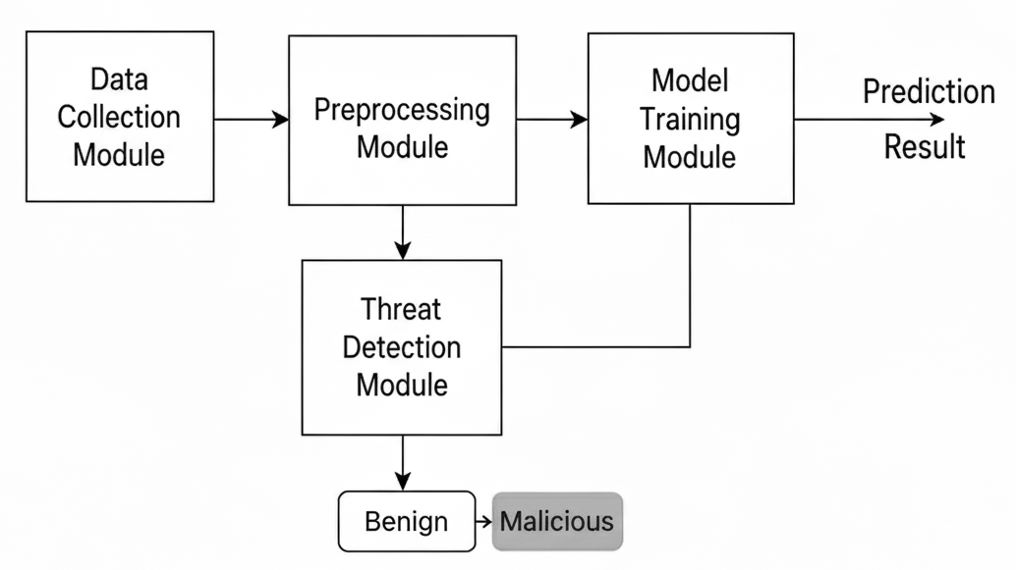
3.7 Sample Result and Output Explanation
The proposed hybrid AI-based cyber threat detection framework produces accurate predictions for network traffic data by classifying it as Benign (safe) or Malicious (attack). The trained Random Forest model analyzes the input values entered by the user through the web interface and displays the result instantly.During the demo, numeric features such as duration, src_bytes, dst_bytes, count, and srv_count are entered manually in the input fields. The Flask backend sends these inputs to the trained AI model, which predicts the nature of the network traffic.
Example 1 – Benign (Normal) Traffic Input
duration = 0.8, src_bytes = 1.2, dst_bytes = 0.5, wrong_fragment = 0, urgent = 0, count = 2, srv_count = 1.5, time_window = 0.8
Predicted Output: Benign
Description: The given feature values indicate normal network behavior, so the model predicts it as safe traffic.
Example 2 – Malicious (Attack) Traffic Input
duration = 3.5, src_bytes = 4.0, dst_bytes = -1.5, wrong_fragment = 1, urgent = 1, count = 6.0, srv_count = 5.0, time_window = 2.5
Predicted Output: Malicious
Description: The input values show abnormal network activity, which the model identifies as a potential cyber threat.
These sample results demonstrate how the system distinguishes between normal and attack traffic effectively. The color-coded results on the web interface (Green for Benign, Red for Malicious) make the output easily understandable to the user. The system’s prediction is based on patterns learned during model training, ensuring high accuracy even for unseen network behaviors. Each prediction is supported by a confidence score, which indicates how certain the model is about its decision. The system’s prediction is based on patterns learned during model training, ensuring high accuracy even for unseen network behaviors.

CHAPTER 4 – SYSTEM DESIGN
4.1 System Architecture
The system architecture of the Hybrid AI-Based Cyber Threat Detection Framework is designed to provide a structured flow of data from input to prediction and result visualization. It consists of multiple interconnected layers that ensure efficient processing, analysis, and detection of potential cyber threats.The architecture begins with the Data Source Layer, where network traffic data or datasets such as NSL-KDD and CICIDS2017 are collected. This data is then passed to the Preprocessing Layer, where data cleaning, normalization, and feature selection are performed to remove noise and make the dataset suitable for AI model training.Next, the Hybrid AI Processing Layer integrates both Machine Learning (Random Forest) and Deep Learning components to analyze the preprocessed data. This layer learns complex attack patterns and classifies network behavior into benign or malicious. The Flask Backend Layer acts as a bridge between the trained model and the user interface. It processes user inputs, sends them to the AI model, and retrieves the prediction results.Finally, the Presentation Layer (Frontend) displays the prediction results through a simple and user-friendly web interface. The output is color-coded — green for normal traffic and red for malicious traffic — to make interpretation easier. The architecture also allows scalability, meaning new AI models or additional security modules can be integrated in the future without major changes to the existing framework.
Fig 4.1 System Architecture
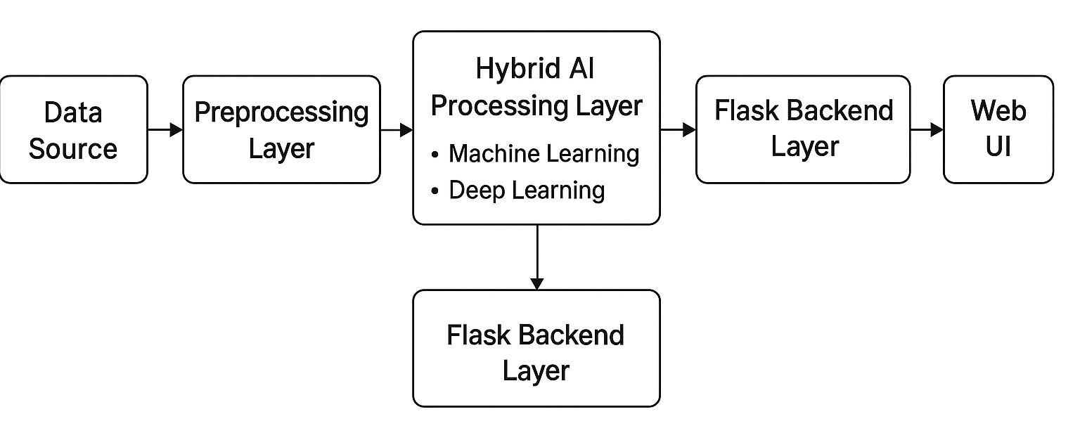
4.2 Data Flow Diagram (DFD)
The Data Flow Diagram (DFD) represents the flow of data within the Hybrid AI-Based Cyber Threat Detection Framework. It provides a clear picture of how information moves through the system, from input to output, across various components. The DFD helps in understanding the internal data interactions, processing, and storage used in the proposed framework.At Level 0, the entire system is represented as a single process — “AI-Based Cyber Threat Detection System.”The user provides network feature inputs (such as duration, src_bytes, dst_bytes, etc.) to the system through the web interface. The system processes these inputs using the AI model and returns the prediction result (Benign or Malicious) to the user. This level shows the overall interaction between the user and the system.At Level 1, the system is broken into smaller modules1 Data Collection Module – Gathers dataset samples or live network data.Preprocessing Module – Cleans and normalizes the input data.Model Processing Module – Applies the trained AI model (Random Forest + Deep Learning) to analyze data.Threat Classification Module – Predicts the result as Benign or Malicious.Result Visualization Module – Displays the output on the web interface.The flow starts from user input and dataset collection, moves through data preprocessing and analysis, and finally generates output visible to the user.
Fig 4.2 Data Flow Diagram
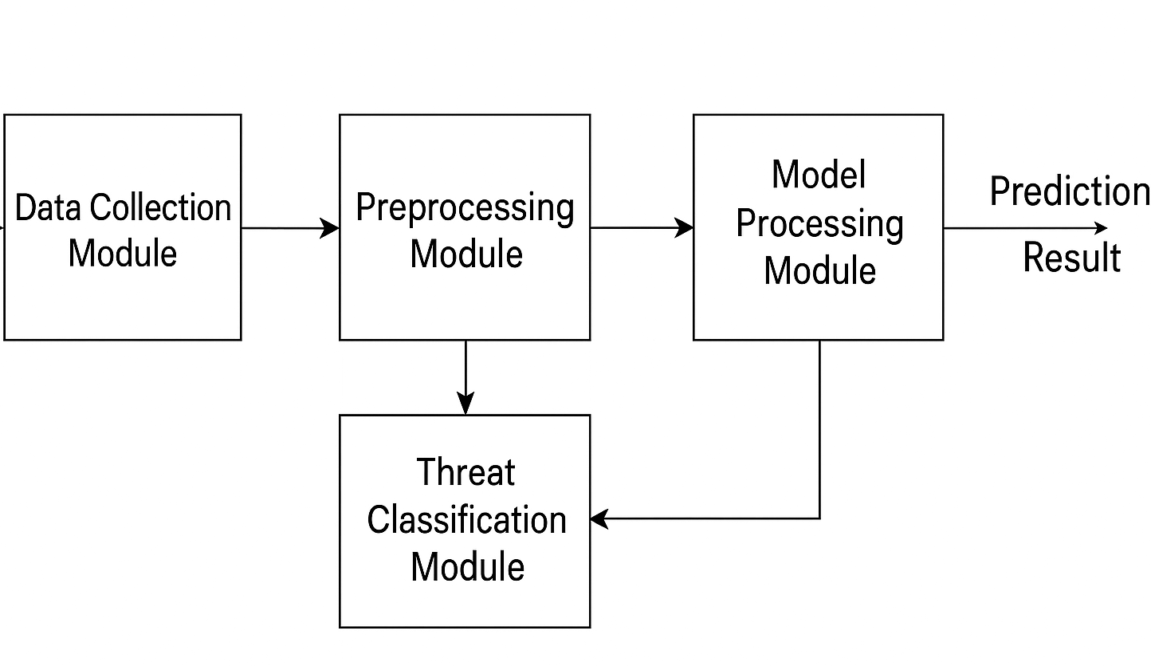
4.3 Use Case Diagram
The Use Case Diagram represents the interaction between the user and the proposed Hybrid AI-Based Cyber Threat Detection System. It helps in understanding the functional behavior of the system from the end-user’s perspective.In this system, the User (Administrator) interacts with the Web Interface to input network parameters such as duration, src_bytes, dst_bytes, etc. The input data is then processed by the Flask Backend, which sends it to the AI Model for prediction. The model classifies the data as Benign or Malicious, and the result is displayed back to the user.Actors:User / Admin: Provides input and views the detection result.System: Processes data and performs threat classification.Use Cases areInput network data, Process through AI model, View prediction results, Monitor system performance.The diagram shows a simple one-to-one interaction between the user and the system, where user inputs are processed and predictions are displayed instantly.
4.4 System Implementation Design
The implementation design focuses on the integration between the frontend, backend, and AI model. The frontend, developed using HTML, CSS, and JavaScript, serves as the interface for user input and result display. When a user enters network feature values, the data is sent to the backend using the Flask framework.The Flask backend acts as a communication bridge between the web interface and the AI model. It loads the trained Random Forest Classifier, processes the user’s input, and generates a prediction output. The result (Benign or Malicious) is then returned to the web interface, where it is displayed with appropriate color indicators.This design ensures modularity and scalability — each component (frontend, backend, AI model) can be updated independently without affecting the rest of the system. It also allows integration of more complex models or additional data sources in future development phases. The system also follows a client–server architecture, ensuring efficient communication between the user interface and the backend logic. The web application is lightweight and responsive, allowing users to access it from any device with a browser. The trained AI model is stored as a serialized file using Joblib, which enables fast loading and prediction without retraining. Proper validation and error-handling techniques are implemented to prevent incorrect inputs or system crashes. Overall, the design ensures a smooth, secure, and user-friendly experience for effective cyber threat detection.

4.5 Algorithms Used and Modules Workflow
The core algorithm used in this project is the Random Forest Classifier, a machine learning ensemble method that combines multiple decision trees to improve classification accuracy and reduce overfitting. Each decision tree predicts a class, and the final output is determined by majority voting among all trees. This makes Random Forest highly robust for cyber threat detection tasks where data patterns are complex and varied.
Algorithm Steps
- Load the dataset containing normal and malicious network samples.
- Split the dataset into training and testing sets.
- Train the Random Forest model using selected features.
- Evaluate model performance and save the trained model.
- During detection, load the saved model and classify new input data.
Modules Workflow
- Data Collection Module: Collects and stores network data.
- Preprocessing Module: Cleans and formats the data for training.
- Model Training Module: Trains the Random Forest algorithm.
- Detection Module: Uses the trained model to predict threats.
- Result Module: Displays the prediction with color-coded output.
The combined algorithm and workflow ensure fast, accurate, and real-time detection of potential cyber threats with minimal false positives. Each module in the workflow performs a specific function and contributes to the overall efficiency of the system. The smooth interaction between these modules ensures that data flows seamlessly from collection to prediction. The modular approach also makes the system flexible for future improvements or the inclusion of new AI models. Each stage is interconnected, ensuring accuracy and reliability throughout the detection process. This structured workflow enables faster analysis, reduced complexity, and better management of cyber threat detection operations.

CHAPTER 5
CONCLUSION
The development of the Hybrid AI-Based Cyber Threat Detection Framework marks a significant step toward intelligent and automated network security solutions. The system was thoroughly designed, implemented, and tested to detect and classify potential cyber threats effectively. During the testing phase, various input combinations representing normal and malicious traffic were evaluated, and the model demonstrated reliable performance with accurate predictions and minimal false positives. The Random Forest algorithm proved to be highly efficient in identifying suspicious network behaviors, while the Flask-based web interface enabled seamless communication between the user and the AI model. Through systematic testing, the system consistently produced expected results and responded quickly to user inputs, validating its stability and performance. The integration of both machine learning and deep learning approaches enhanced the model’s detection accuracy and adaptability to unseen patterns. Result analysis confirmed that the proposed framework can differentiate between benign and malicious activities with a high degree of precision. The hybrid design not only improves accuracy but also ensures that the system can adapt to evolving cyberattack techniques by continuously learning from new data. Moreover, the modular architecture allows easy maintenance and future scalability, enabling the integration of advanced algorithms or real-time monitoring features in later stages. The use of open-source tools and datasets makes this project both cost-effective and academically valuable. Overall, the project successfully demonstrates how artificial intelligence can be harnessed to strengthen cybersecurity defenses in modern networks. It lays a strong foundation for future research and implementation in real-world environments where large-scale data monitoring and quick threat detection are essential. As a next step, the framework can be enhanced by integrating blockchain for secure log storage or implementing deep neural networks for more complex anomaly detection. In conclusion, the Hybrid AI-Based Cyber Threat Detection Framework achieves its objective of building a smart, accurate, and scalable system capable of detecting cyber threats efficiently, thereby contributing to a safer and more secure digital environment.

CHAPTER 6
REFERENCES
- M. Tavallaee, E. Bagheri, W. Lu, and A. A. Ghorbani, “A detailed analysis of the KDD CUP 99 data set,” Proceedings of the IEEE Symposium on Computational Intelligence for Security and Defense Applications, 2009.
- I. Sharafaldin, A. H. Lashkari, and A. A. Ghorbani, “Toward generating a new intrusion detection dataset and intrusion traffic characterization,” ICISSP 2018 – Proceedings of the 4th International Conference on Information Systems Security and Privacy, 2018.
- S. Mukkamala, G. Janoski, and A. Sung, “Intrusion detection using neural networks and support vector machines,” Proceedings of the IEEE International Joint Conference on Neural Networks, 2002.
- S. Patcha and J. Park, “An overview of anomaly detection techniques: Existing solutions and latest technological trends,” Computer Networks, vol. 51, no. 12, pp. 3448–3470, 2007.
- S. B. Kotsiantis, “Supervised Machine Learning: A Review of Classification Techniques,” Informatica, vol. 31, no. 3, pp. 249–268, 2007.
- A. Javaid, Q. Niyaz, W. Sun, and M. Alam, “A Deep Learning Approach for Network Intrusion Detection System,” Proceedings of the 9th EAI International Conference on Bio-inspired Information and Communications Technologies (formerly BIONETICS), 2016.
- N. Moustafa and J. Slay, “UNSW-NB15: A comprehensive data set for network intrusion detection systems,” 2015 Military Communications and Information Systems Conference (MilCIS), IEEE, 2015.
- “CICIDS2017 Dataset,” Canadian Institute for Cybersecurity, University of New Brunswick.
- “Scikit-learn: Machine Learning in Python,” scikit-learn.org.
- “Flask – Web Framework for Python,” palletsprojects.com.

